

**Module:** --------

**Coursework Title:** Group Assignment

**Intake**: ---------

**Lecturer name:** ------------

**Student Name and ID:**

**--------------------**

**------------------**

**Due date**: ---------

Contents

Acknowledgment 3

Introduction 4

Algorithm 5

Flowchart 5

User Manual 6

Data Base 6

Main menu 7

Order module 8

Payment module 11

Report module 12

Critical Assessment 14

References 15

# Acknowledgment

The following assignment has been completed with a great cooperation of groupmates, their dedication and hard work. One of the most important aspects that lead to the successful accomplishment was proper communication among team members. Among the line, we would like to bring our sincere appreciation to our Fundamentals of Software Development lecture. Throughout the entire modules, lab and lecturer sessions, he was dedicated and always ready to answer any kind of question asked by students. Without his help and brief introduction to the module we wouldn’t be able to accomplish this take. Now coming to the end, we hope to share all the knowledge gained through this module in future with upcoming students.

# Introduction

Catering systems are complex sociotechnical organizations including both people and machinery in the production and service of food. The objective for the management of any system is to discover ways of guaranteeing its long-term survival and growth, often by seeking gains in efficiency and effectiveness in producing its outputs. Systems have the key goal of transforming a diverse blend of ‘inputs’ into desired ‘outputs.’ The main objective of developing this Catering Management System is to make catering system simple and dynamic. The output of the project contains food menu and additional services with different navigation functions those are make orders, make payments, chose service and menu, display invoice and summary of orders.

# Algorithm

## Flowchart

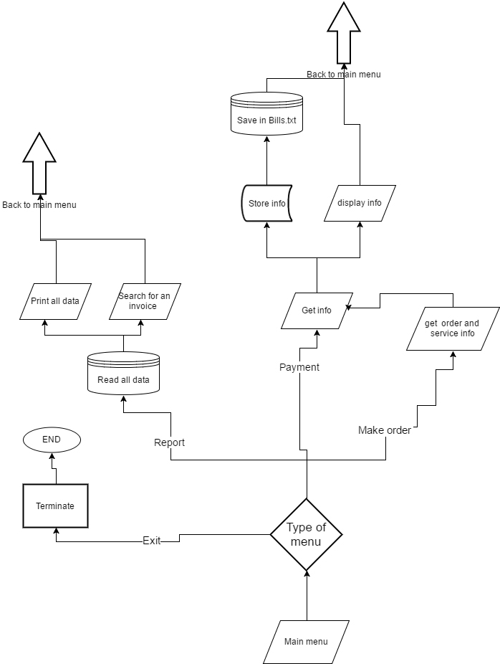

# User Manual

## Data Base

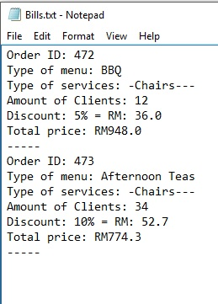

System using one data base (Bills.txt), which stored (order ID, type of menu, type of service, amount of clients per order, discount and total price). However, first ID of the order writes randomly, but while system running it will increase previous ID by one (1) each time when user make new order.

## Main menu

When user start a program, will opened ‘Main Menu’. That contained four functions: Order, Report, Payment and Exiting. To go to the Order page, user supposed to press ‘O’ or ’o’, ’R’ or ‘r’ for report, ‘P’ or ‘p’ for payment and ‘E’ or ‘e’ for exiting. If the user enters any another character, will again opened ‘Main Menu’.

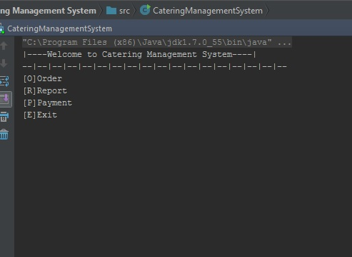

## Order module

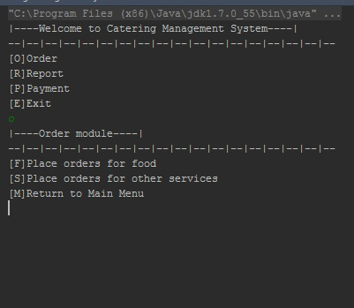In Order menu user could choose, place order for food or place order for another services and return to ‘Main menu’.

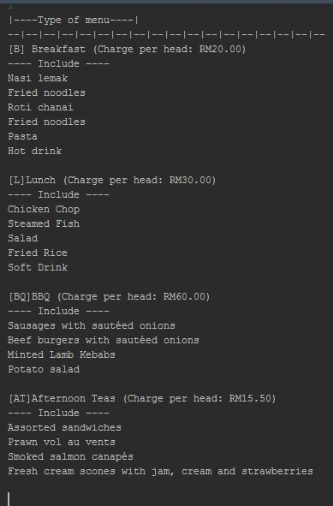

When user select place order for food, will open a page with ‘Type of menu’. Each menu is designed for one person.

When user select some type of menu, system will ask number of clients. After, user will process to order information block. In this block will be printed Type of menu, Discount and Total price. Moreover, discount depended form amount of client.

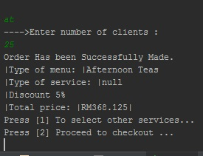

In the same time, system will ask, choose to options:

1)‘To select other services’

2) ‘Proceed to checkout’.

If input not equal to “1”, “2” or will be empty system open ‘Main Menu’ and the order will have to do again.

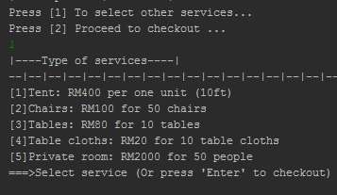

When user select first case ‘To select other services’, system give you opportunity to choose 5 services.

For example, when user chose first case “[1]Tent:…’’ system will asking about quantity of units and show total price of services, after system propose to choose more services. When user press ‘Enter’ system switch him to information block, where counted all information (Food menu and Services). Next, the user has a choice, add more services or processed to payment module.

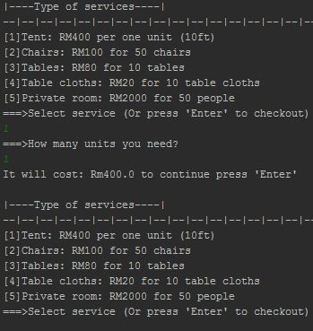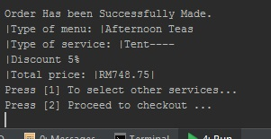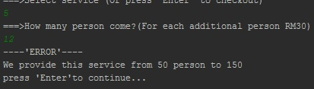

Fifth service have limitation, because available just from 50 to 150 person, for each additional 10-person system count extra RM30.

## Payment module

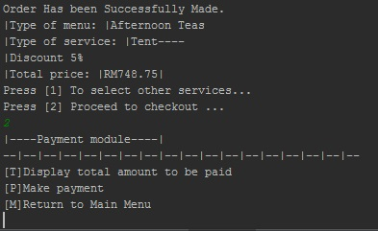

On this stage, user have opportunity to choose three case. First is, display total amount to be paid. Second, make payment and third return to main menu.

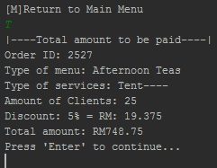

When user select first case, system will be showing all information about particular order, even total amount of discount. After operator pressed any button, system send him back to payment module.

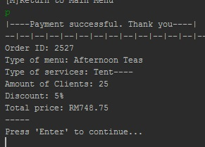

After, user choose payment module, system will be printing final bill and save it to data base(Bills.txt).

## Report module

In report module, user could choose three cases, first case ‘display the invoice for order made’. Second, “display summary of orders and payments made’ and last one return to main menu.

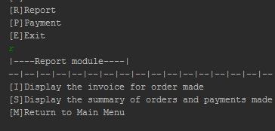

When user select first case, system will ask to enter ID of the order. After, system checking all data in data base (Bills.txt), if order was founded, this order will be displaying. However, if order not in a data base, system will be displaying massage ‘Order was not found’.

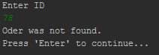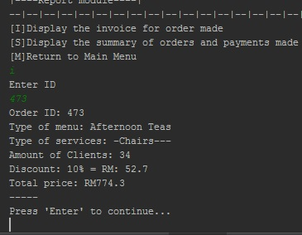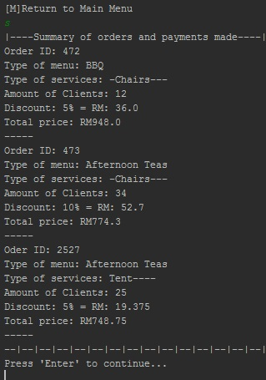

When user choose second case, system check each string in data-base and print all what there saved.

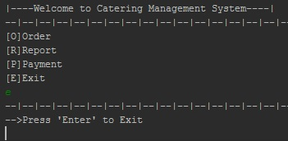

Last function is ‘Exit’. After user select this case system will be asking to press any button, then the system will close.

# Critical Assessment

The program developed officially meets all the requirements and specifications. Additionally, the Catering Managment System can be improved in many aspects and limitations are only set by the developer or the programmers’ imaginations. In my opinion, Software development is unlimited resources and if use it properly developer could realize all what he wants. In this Catering Management System was not implemented many features, such as deleting, update an order, schedule of events, count quantity of food that available and that was sold. Moreover, system supposed to track status of order. System should to maximize interdependence with the environment within which they exist.

However, this system has strengths such as unlimited amount of ordering, no unlimited loop, unlimited database, clean database. Overall, the system has been successfully completed and all the use cases are working properly. Comparing the system to the knowledge gained throughout lecturer and lab sessions, our team members have done a very well job and there is always a room for an improvements which we are planning to make in upcoming levels with more knowledge we gain about programming languages. Furthermore he was able to describe

# References

Eckel, B. (2006). *Thinking in Java*. 1st ed. Upper Saddle River, NJ: Prentice Hall.

development, J. (2016). *Intro to Java programming*. [online] Ibm.com. Available at: https://www.ibm.com/developerworks/learn/java/intro-to-java-course/index.html [Accessed 16 Dec. 2016].

Stackoverflow.com. (2016). *Newest 'java' Questions*. [online] Available at: http://stackoverflow.com/questions/tagged/java [Accessed 16 Dec. 2016].

Stravaganzastravaganza.blogspot.my. (2016). *CATERING SYSTEMS*. [online] Available at: http://stravaganzastravaganza.blogspot.my/2012/03/catering-systems.html [Accessed 17 Dec. 2016].